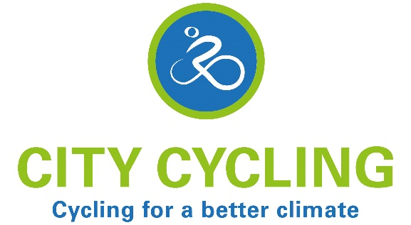
WELCOME TO
CITY CYCLING!
City Cycling or STADTRADELN is an amateur cycling competition. It is a campaign of the European agency – Climate Alliance https://www.climatealliance.org/home.html . Teams of at least two (2) cyclists compete over a 21-day period to cover as many kilometers as possible. The competition aims to protect the climate, promote cycling and improve the quality of life in municipalities and, ultimately, have fun!

Why has Newport News joined CITY CYCLING?
Newport News is the 1st US city to participate in City Cycling. We joined City Cycling at the request of our German Sister City - Greifswald (Mecklenburg-Vorpommern). Greifswald has participated in “STADTRADELN” since 2015. CITY CYCLING provides a creative way for citizens in both communities to safely connect and exchange during a global pandemic. Last year, 2,172 cities with over 800,000 cyclists participated word wide in the competition, cycling over 1.5 million kilometers. Greifswald cycled 326,266 kilometers and finished #154. Newport News cycled 28,778 kilometers finishing# 1,281. Sister Cities of Newport News, Inc. is proud to be the non-profit managing City Cycling USA in our community.

When is the competition?
May 1-21, 2022: Newport News (USA) and Greifswald (GERMANY) share the same cycling dates.

Who is able to participate?
Anyone who lives, works, belongs to a club or attends school or university in Newport News.

How can I sign up?
- DOWNLOAD the City Cycling App on your smart phone: https://www.city-cycling.org/app
- Or go to: https://www.city-cycling.org/sign-up
- Choose “Other than Germany”; select NEWPORT NEWS!
- Join an existing team or form a new one. Newport News has an “open team” that you are able to join.
- If you decide to form a new team, you will automatically be designated the team captain. You must belong to a team – after all, climate protection and cycling promotion require teamwork!
- You can join, or form a team up, until the very last day of the 21-day campaign period, or May 21st .

How do I collect miles (kilometers)?
- DOWNLOAD the City Cycling App on your smart phone: https://www.city-cycling.org/app
- GET CYCLING! You do NOT have to cycle in Newport News; climate protection knows no boundaries.
- RECORD the kilometers cycled for just you or, your team. You can record for multiple cyclists (e.g., entire families, school classes, etc.) in the same online cycling log. IMPORTANT: be sure to indicate the exact number of people for whom you are entering kilometers!
- Kilometers can be entered retroactively as long as they were covered during the 21-day period.
- There is a seven-day grace period after the local campaign period ends for cyclists to finalize their logs. No new entries or changes are possible after May 27th!

Who is in the lead?
- The results of all participating municipalities and teams will be published on city-cycling.org/results
- And, while it is unlikely that we will beat Greifswald, Newport News is leading the way in the USA!

